DATABASE SCHEMA

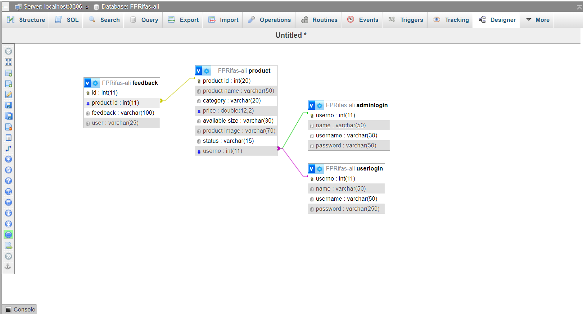

USER LOGIN TABLE
userno | name | username | password
122 | UserName1 | user1 | password1
123 | UserName2 | user2 | password2
124 | UserName3 | user3 | password3
125 | UserName4 | user4 | password4
126 | UserName5 | user5 | password5
128 | UserName6 | user6 | password6
129 | UserName7 | user7 | password7

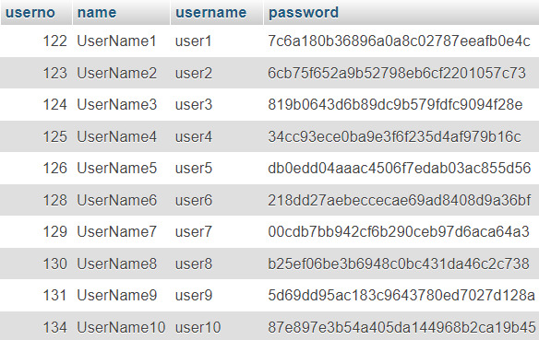
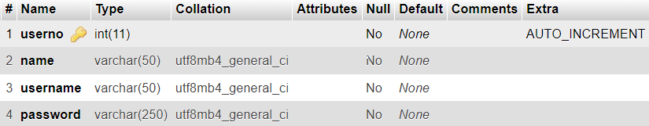

ADMIN LOGIN TABLE
userno | name | username | password
344 | Admin1 | adminuser1 | pass1
345 | Admin2 | adminuser2 | pass2
346 | Admin3 | adminuser3 | pass3
347 | Admin4 | adminuser4 | pass4
348 | Admin5 | adminuser5 | pass5
351 | Admin6 | adminuser6 | pass6
352 | Admin7 | adminuser7 | pass7

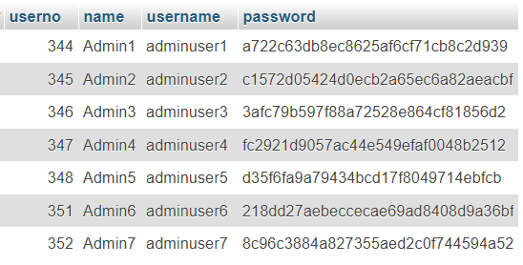
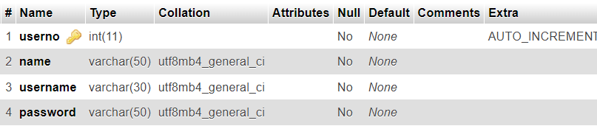

PRODUCT TABLE

product id | product name | category | price | available size | product image | status | userno
23498 | Mens Bottom | mens | 21.00 | s,m,xl | bottom2.jpg | in-stock | 345
23654 | Mens Printed Shirt | mens | 23.00 | s,m,xl | shirts2.jpg | out of stock | 346
24965 | Mens Bottom | mens | 23.00 | s,m,l | bottom4.jpg | out of stock | 347
25148 | Girls Top | girls | 17.00 | s,m,l | girls-top2.jpg | out of stock | 348
25669 | Womens Top | womens | 23.00 | s,m,xl | tops2.jpg | in-stock | 344
26548 | Mens Printed Shirt | mens | 26.00 | s,m,xl | shirts1.jpg | in-stock | 345
26874 | Girls Dress | girls | 22.00 | s,m,xl | girls-dresses4.jpg | in-stock | 346

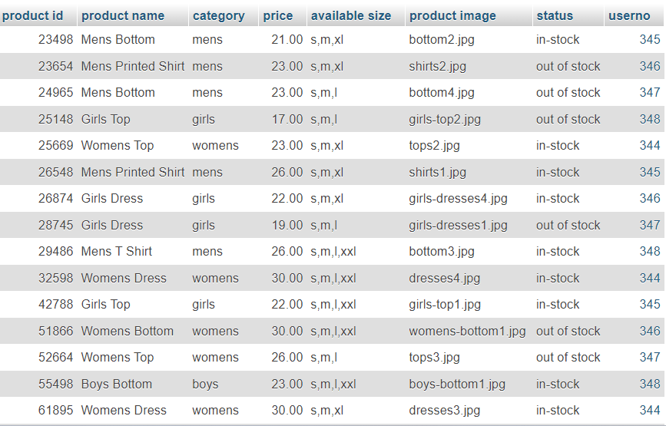

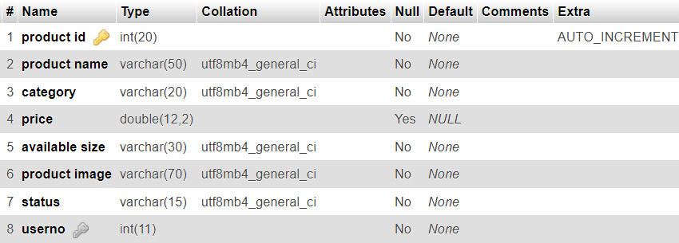

FEEDBACK TABLE

id | product id | feedback | user
1 | 23654 | Nice Color | UserName2
2 | 24965 | Good Quality | UserName2
3 | 29756 | Always out of stock | UserName2
4 | 29486 | Great Fit | UserName1
5 | 65412 | Best Party Wear | UserName1
6 | 22648 | Great for winters | UserName1
7 | 51866 | Horrible | UserName1

